WEEKLY REPORT and MEETING AGENDA

Report #: 2 Project Name: Soil Moisture Sensor Network
Date: 11/5/2017 Prepared by: Kerry Zeng

Agenda for the meeting
- Discuss progress, impediments, and plans.
- Brainstorm solutions and other plans.
- Distribute work for the week.
- Work on the project.
- Discuss what we accomplished during the meeting.

Overall accomplishments since last meeting
- 3d printed materials
- Wrote test client and server for saving some dummy data into database
- Successfully sent moisture readings from Bluno to Raspberry Pi 3 over Bluetooth

Tasks completed by each team member since last meeting

Task description | Assigned to | Completed?
Write endpoints for server | Kerry | Yes
Establish Bluetooth Server on Raspberry Pi | Curtis | Yes
Solder and make battery powered sensors without the encasing | Jingyu | Yes
3d Print Encasings | Henry | Yes
Documentation for Raspberry Pi setup |  | Yes

Plans for next period
- Combine casings, sensor, microcontroller, and power supply.
- Test the hardware’s range, waterproofing, and durability.
- Write Client software for Raspberry Pi 3 to queue data from Arduino and send to server.
- Test Arduino codes and optimize.
- Review other senior design code.

Task assignment per team member (to be completed before the next meeting)

Task description | Assigned to
Write endpoint for the client to receive requests from server | Kerry
Combine casings | Henry
Test hardware | Jingyu
Write Client software and optimize | Curtis
Review Senior design code | Hunter

Project management status
- The project is on track for completion. A lot of progress was made in the initial set up and most of the core functionality is done. It still needs some work in combining each part because of how much we parallelized the work. Additionally, we need to optimize the code in general once we do combine it. The hardware is nearly complete, but we ran into an issue with the power supply and we may need to change the power supply to a different type of battery. We’ve 3d printed some samples for the casings and are just waiting on it and after that the hardware should be almost done.
- The team is getting a long a lot better. People are definitely meshing more this week than last week, but there’s still a little bit of disconnect between members. Overall, it’s still better than most other teams that I have been in.
- Henry purchased the battery casings for the Triple A batteries, but found out that two of them in series wasn’t enough power to use the Bluetooth Low Energy feature. We will need to test other ways to power it. Additionally, he ordered the 3d printed casings and it will arrive on Tuesday.

Minutes from previous meeting
- Kerry is working on the server and was able to serialize and parse the data on the client/server side. He is working on the SQL statements to save the data into the database. He had some trouble writing the SQL Statements.
- Henry was working on creating more connected battery components for the Arduinos. He also ordered the 3d printed parts and will be going to Houston on Tuesday to pick it up.
- Hunter worked on writing documentation to set up Bluetooth for the Raspberry Pi 3
- Curtis was working on a program that accepts the signals from the Arduino and figuring out a good scheduling scheme for communication.
- Jingyu was working with Henry on soldering and creating the casings
- Discussed ways to solve the database issues
- Each member worked on their separate tasks for around 3 hours.
- Discussed progress and assigned tasks.

Accomplishments:
3d printing designs
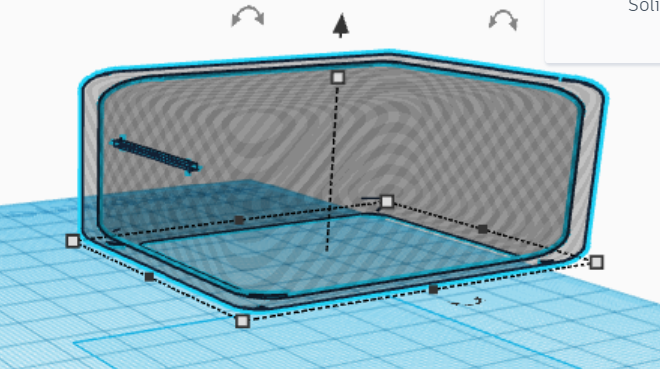
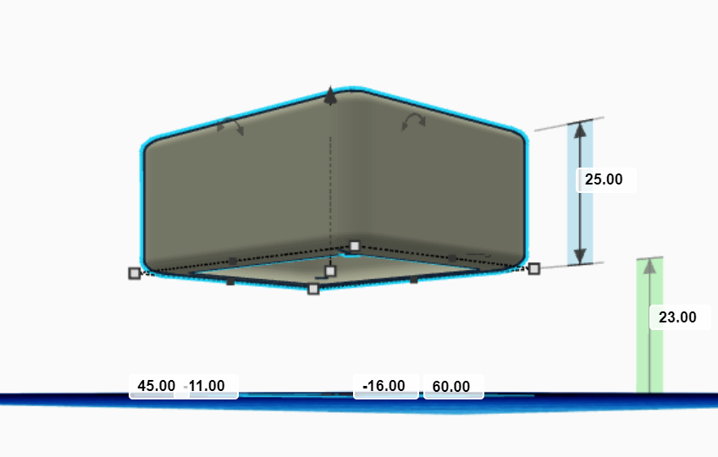

Arduino-Raspberry Pi 3 Moisture Reading Communication

